**Lab Report**

Title: Lab 0

Notice: Dr. Bryan Runck

Author: Diego Osorio

Date: 9/21/2022

**Project Repository:** https://github.com/osori050/GIS5571/tree/main/Lab0

**Google Drive Link:**

**Time Spent:** 28 h

**Abstract**

The ESRI ecosystem provides different ways to access the same functionality by using different tools. In this lab, ArcPro alone, Jupyter Notebooks in ArcPro, and Jupyter Notebooks in ArcOnline were utilized to create a 100-meter buffer for the road network of Rice County, Minnesota. The three methods yielded the same result with high accuracy. Besides, for this specific task, ArcPro alone showed to be the most straightforward tool. Additionally, the lab included a quick start guide with GitHub and Git.

**Problem Statement**

ESRI has created different ways to integrate Python language with ArcProducts. ArcPro allows users to run tools from the arcpy library as well as other open-source libraries. Likewise, it has included the interactive Jupyter Notebooks which helps carry out the GIS analysis more dynamically through features such as code and markdown cells, among others. Similarly, ArcOnline has integrated these notebooks which open the opportunity for countless GIS analyses thanks to the vast availability of information on this portal. In this way, this lab aims to compare through three methods the buffering functionality developed by ESRI over a road network in Rice County, Minnesota.

Additionally, this lab includes a quick start with GitHub and Git, two great means to create repositories to share projects and contribute with peers.

Table 1. Requirements for the buffer analysis

|  |  |  |  |  |  |  |
| --- | --- | --- | --- | --- | --- | --- |
| **#** | **Requirement** | **Defined As** | **(Spatial) Data** | **Attribute Data** | **Dataset** | **Preparation** |
| 1 | Road network | Raw input dataset from Rice County, Minnesota | Road geometry (line) |  | [Mn GeoSpatial Commons](https://gisdata.mn.gov/dataset/trans-roads-mndot-tis) |  |
| 2 |  |  |  |  |  |  |
| 3 |  |  |  |  |  |  |

**Input Data**

This is a polyline shapefile that defines the location of the roads in Rice County. The data does not have any constraints and was updated on March 8, 2022. The horizontal coordinate scheme is Minnesota County Coordinate System NAD83 and the bounding coordinates are from 44.19 to 44.55 latitude, and from -93.03 to -93.53 longitude. Some roads were created by utilizing COGO in ArcMap. When information was not available, the roads were created by using heads-up digitizing.

Table 2. Input data

|  |  |  |  |
| --- | --- | --- | --- |
| **#** | **Title** | **Purpose in Analysis** | **Link to Source** |
| 1 | Roads, Rice County, Minnesota | Dataset for proximity analysis of the location of the roads in Rice County | [Mn GeoSpatial Commons](https://gisdata.mn.gov/dataset/trans-roads-mndot-tis):  https://gisdata.mn.gov/dataset/us-mn-co-rice-trans-roads |
| 2 |  |  |  |
| 3 |  |  |  |

**Methods**

* ArcPro

The input data was added onto ArcPro and the Python window was selected to run the buffer tool to get a new 100-meter buffer shapefile as shown in Figure 1.

Figure 1. Workflow in ArcPro

* Jupyter Notebooks in ArcPro

Here, the arcpy module was imported and then, using the same piece of code as above, a 100-meter buffer was created for the input data as shown in Figure 2.

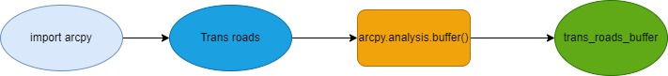

Figure 2. Workflow in Jupyter Notebooks in ArcPro

* Jupyter Notebooks in ArcOnline

This method is a bit different from the other two above. First, the modules GIS and use_proximity were imported from the arcgis.gis and arcgis.features libraries, respectively. Then, the input data was added using the gis.content.get() function (this shapefile was previously added to ArcOnline by using the Share As Web Layer tool in ArcPro). Finally, by utilizing the buffer function, a 100-meter buffer was created for the road network. The process is shown in Figure 3.

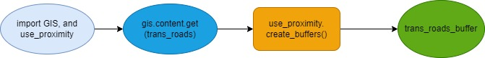

Figure 3. Workflow in Jupyter Notebooks in ArcOnline

**Results**

The three methods yield the same result with high accuracy. ArcPro showed to be the most straightforward method to apply, whereas ArcOnline was the most complex due to the number of new libraries and functions used. Figure 4 through Figure 6 show the buffers obtained with each method.

Figure 4. Buffer with ArcPro

Figure 5. Buffer with Jupyter Notebooks in ArcPro

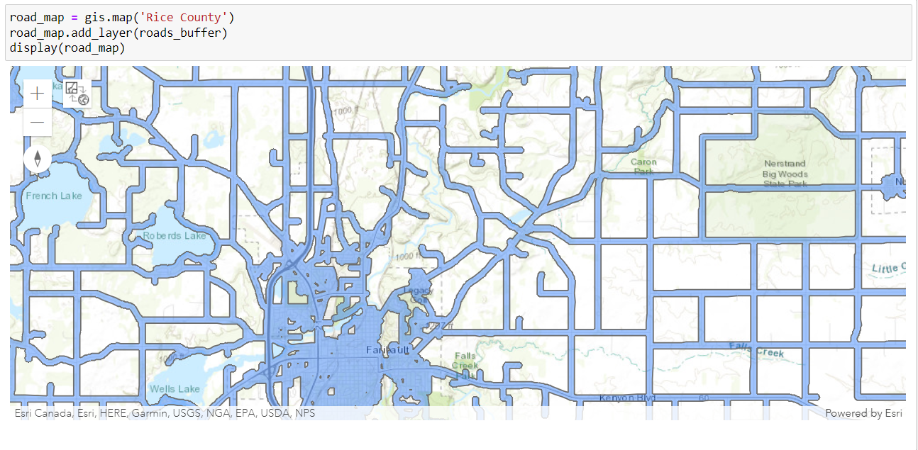

Figure 6. Buffer with Jupyter Notebooks in ArcOnline

**Results Verification**

The results are consistent throughout the 3 methods. Furthermore, the Measure Distance tool on ArcPro was utilized to confirm the buffer is 100 m.

**Discussion and Conclusion**

* GitHub

The creation of the repositories as well as adding, committing, pushing, and pulling the changes to github.com went well. The tutorial in Step 2 was handy to get me familiar with GitHub and Git. This tutorial was better at explaining the processes to follow than the instructions in Step 1 thanks to the text boxes and diagrams. On the other hand, I am still struggling with setting up my username and email for every repository on my computer as every time I start Git, I need to do it from scratch. That is, I have not found a way to set them up as default.

* ArcPro, Jupyter Notebooks, and ArcOnline

The process was smooth in the first two methods: due to my familiarity with ArcPro, the buffer creation using ArcPro alone and Jupyter Notebook in ArcPro was much easier than in ArcOnline. For the latter, I had to look for tutorials to find the packages I needed to import to add the data, create the buffer, and map the results. In conclusion, this exercise was very useful to get to know the different ways to perform the same functionality using different tools.

**References**

GeoMarvel. (2021, March 25). Getting Started with ArcGIS Notebooks (Part 1) [YouTube Video]. Retrieved from https://www.youtube.com/watch?v=QYRPH71TgV0

Rice County MN. (2022, August 3). Roads, Rice County, Minnesota [Shapefile]. Minnesota, USA. Retrieved from https://gisdata.mn.gov/dataset/us-mn-co-rice-trans-roads

**Self-score**

|  |  |  |  |
| --- | --- | --- | --- |
| **Category** | **Description** | **Points Possible** | **Score** |
| **Structural Elements** | All elements of a lab report are included **(2 points each)**:  Title, Notice: Dr. Bryan Runck, Author, Project Repository, Date, Abstract, Problem Statement, Input Data w/ tables, Methods w/ Data, Flow Diagrams, Results, Results Verification, Discussion and Conclusion, References in common format, Self-score | 28 | 28 |
| **Clarity of Content** | Each element above is executed at a professional level so that someone can understand the goal, data, methods, results, and their validity and implications in a 5 minute reading at a cursory-level, and in a 30 minute meeting at a deep level **(12 points)**. There is a clear connection from data to results to discussion and conclusion **(12 points)**. | 24 | 24 |
| **Reproducibility** | Results are completely reproducible by someone with basic GIS training. There is no ambiguity in data flow or rationale for data operations. Every step is documented and justified. | 28 | 28 |
| **Verification** | Results are correct in that they have been verified in comparison to some standard. The standard is clearly stated **(10 points)**, the method of comparison is clearly stated **(5 points)**, and the result of verification is clearly stated **(5 points)**. | 20 | 20 |
|  |  | 100 | 100 |